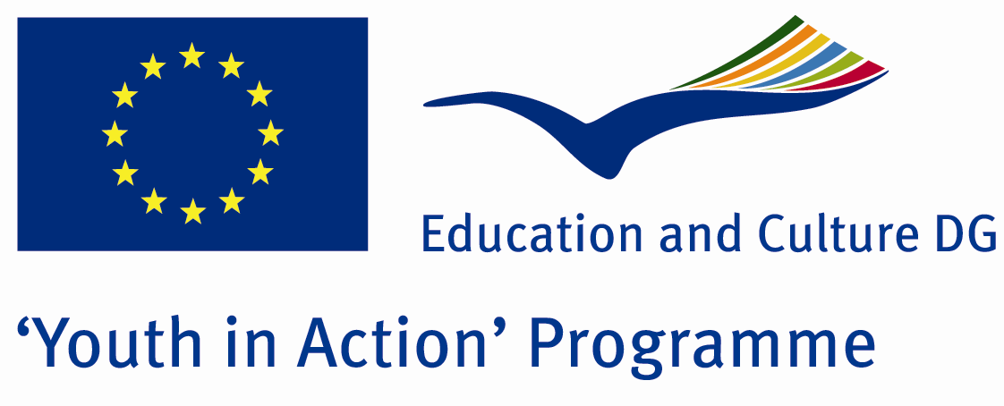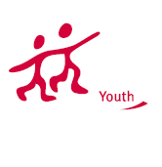

Quick and Deadly



ACTION 4.3 – Training And Networking

23-28th September , 2011

Usak , TURKEY
ACTION 4.3 – Training And Networking

Please contact directly to;
adventurerpeacepigeons@gmail.com

Project Summary;

For 2010, 15 million new cancer cases…because of cancers,8 millions deaths ve 30 millions cancerous people in the world…you know anymore that we face to face what kind of problem is.what about reasons?foods, beverages,e.t.c…now, in most of the foods, there are too many carcinogen elements…the people dont know this or dont car efor this.because, it shows their effects after 15 years later.and if people dont loose their friends or families because of cancer,they dont give enough importance for this..but they must…because the time is passing.it is getting faster day by day…so we must prevent this…but how? Answer:organic agriculture…it is so important…come and join us..you will learn too many things…

Project Title; Quick and Deadly

Date and Venue ; 23-28th September , 2011 Usak, Turkey .

Target Group ; Municipalities, City Councils and Non-Governmental organizations,
youth groups,culture and art groups,e.t.c

Participants ; 5 people from each country (over 18 -25 ). Totally 8 countries.

Conditions ; Accommodation, board and programme costs will be financed through European Commission Youth in Action Programme ….Travel costs will be reimbursed in 70% (APEX Tarrifs). Organizations from all 27 EU member countries plus Liechtenstein , Norway and Iceland are eligible to take part.

Working language: English

Organizer; Adventurer Peace Pigeons

How to apply: If you are interested, please send your Part III forms to
by e-mail please. (in word file). Scan Part3 format is enough for application. (Fulfilled Part III which you can find in the attachment, of course signed and stamped) ..

Next step 2;
Original send via regular post to this address please:

Ertan DERİN
Fevzi Çakmak Mahallesi Tuncer Sokak No:6 PENDİK/İSTANBUL/TÜRKİYE
e-mail : adventurerpeacepigeons@gmail.com
Mobile : 0090 542 393 93 90

If you have any questions you may contact with: adventurerpeacepigeons@gmail.com

Deadline for application; until 15th May 2011.

For Further information:
Contact Person
Ertan DERİN
Fevzi Çakmak Mahallesi Tuncer Sokak No:6 PENDİK/İSTANBUL/TÜRKİYE
e-mail : adventurerpeacepigeons@gmail.com
Mobile : 0090 542 393 93 90

